Lab Assignment 14.4 – AI Assisted Coding

Vidhu Sree . D
2303A52400
Batch – 41

Task 1: Responsive Homepage Layout for a Startup Website
Scenario

You are designing a basic homepage for a startup company that needs to look good on desktops, tablets, and mobile devices.

Task Description

- Create a web page structure using HTML that includes: o A header with navigation links

o A main content section

o A footer with basic information

- Use AI assistance to generate responsive CSS using media queries.

- Ensure the layout adjusts smoothly across different screen sizes.

Prompt: Create a responsive homepage layout for a startup website with a header, main content, and footer.

Implementation:
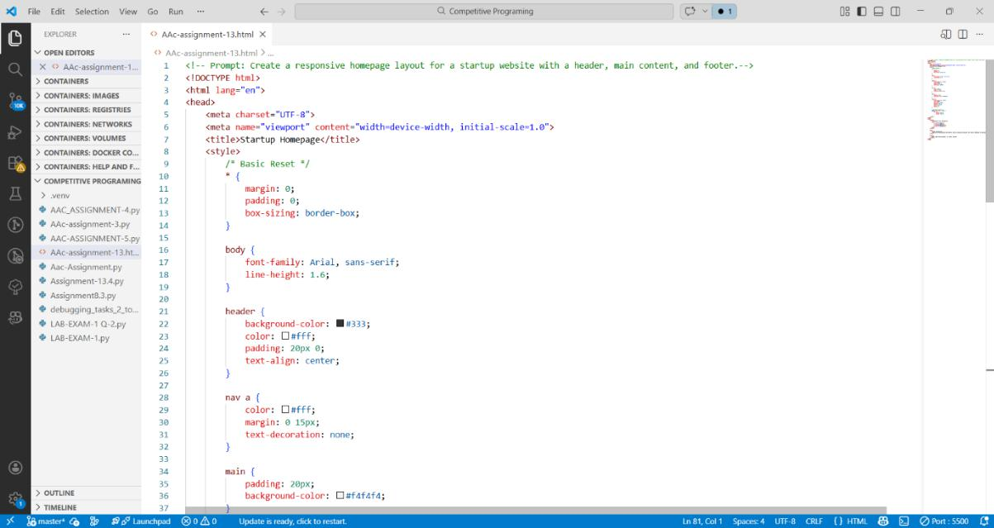

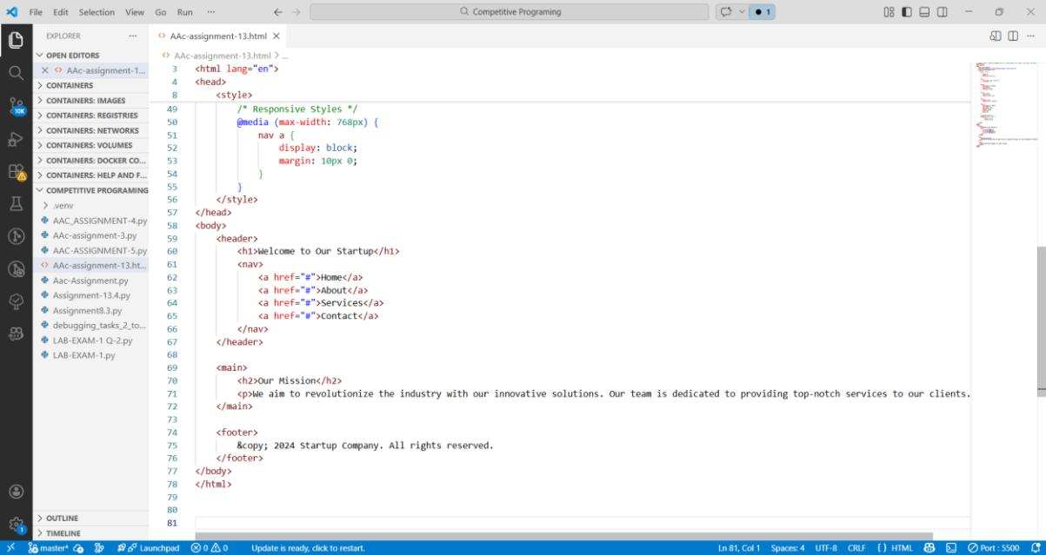

Output:
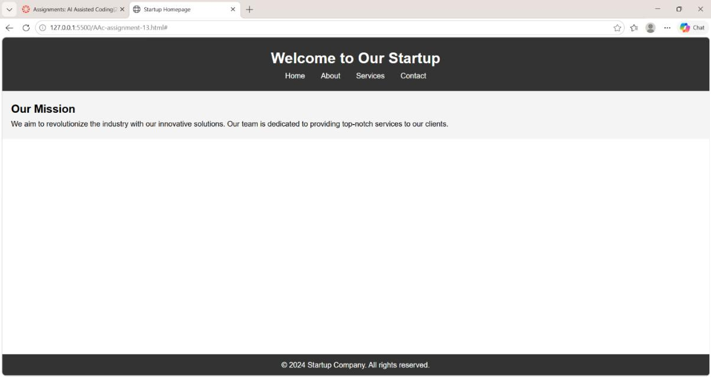

Justification:

The layout is responsive and adapts to different screen sizes using media queries. The header, main content, and footer are clearly separated, and the design is clean and well-structured.

Task 2: Interactive Call-to-Action Button

Scenario

A marketing page requires a call-to-action button that responds when users interact with it.

Task Description

- Add a button to a web page using HTML.

- Use AI to generate JavaScript that responds to the button click by: o Displaying a message or alert

- Ask AI to add meaningful comments explaining the JavaScript logic.

Prompt: Create an interactive call-to-action button that displays an alert when clicked.and add the html code and in the comment the Javascript code should be explained.

Implementation:

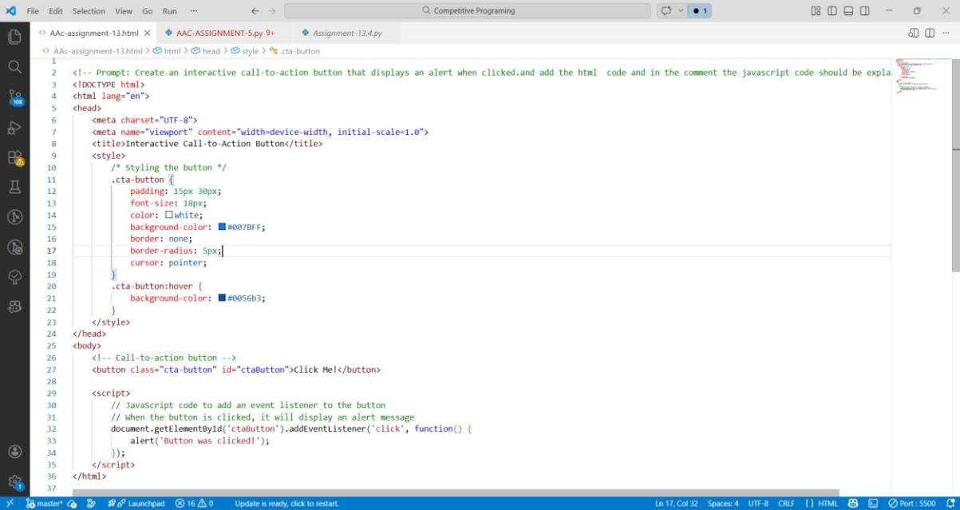

Output:

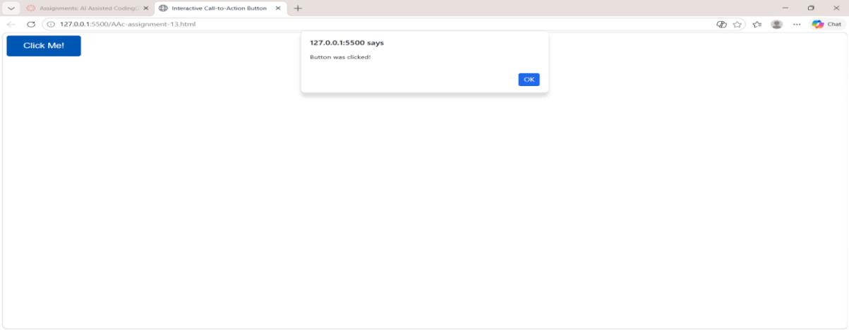

Justification:

The button is styled with CSS to make it visually appealing and interactive. When clicked, it triggers a JavaScript event listener that displays an alert message. This creates an engaging user experience by providing immediate feedback upon interaction.

Task 3: Contact Form with Client-Side Validation

Scenario

You are developing a contact form for a company website to collect user queries safely and correctly.

Task Description

- Design a form with fields for: o Name

o Email

o Message

- Use AI to generate JavaScript validation logic that: o Prevents empty submissions

o Checks for a valid email format

- Display clear error messages for invalid input.

Prompt:

Generate a contact form using HTML and JavaScript with fields for Name, Email, and Message. Include client-side validation to prevent empty submissions, check for valid email format, and display clear error messages.

Code:
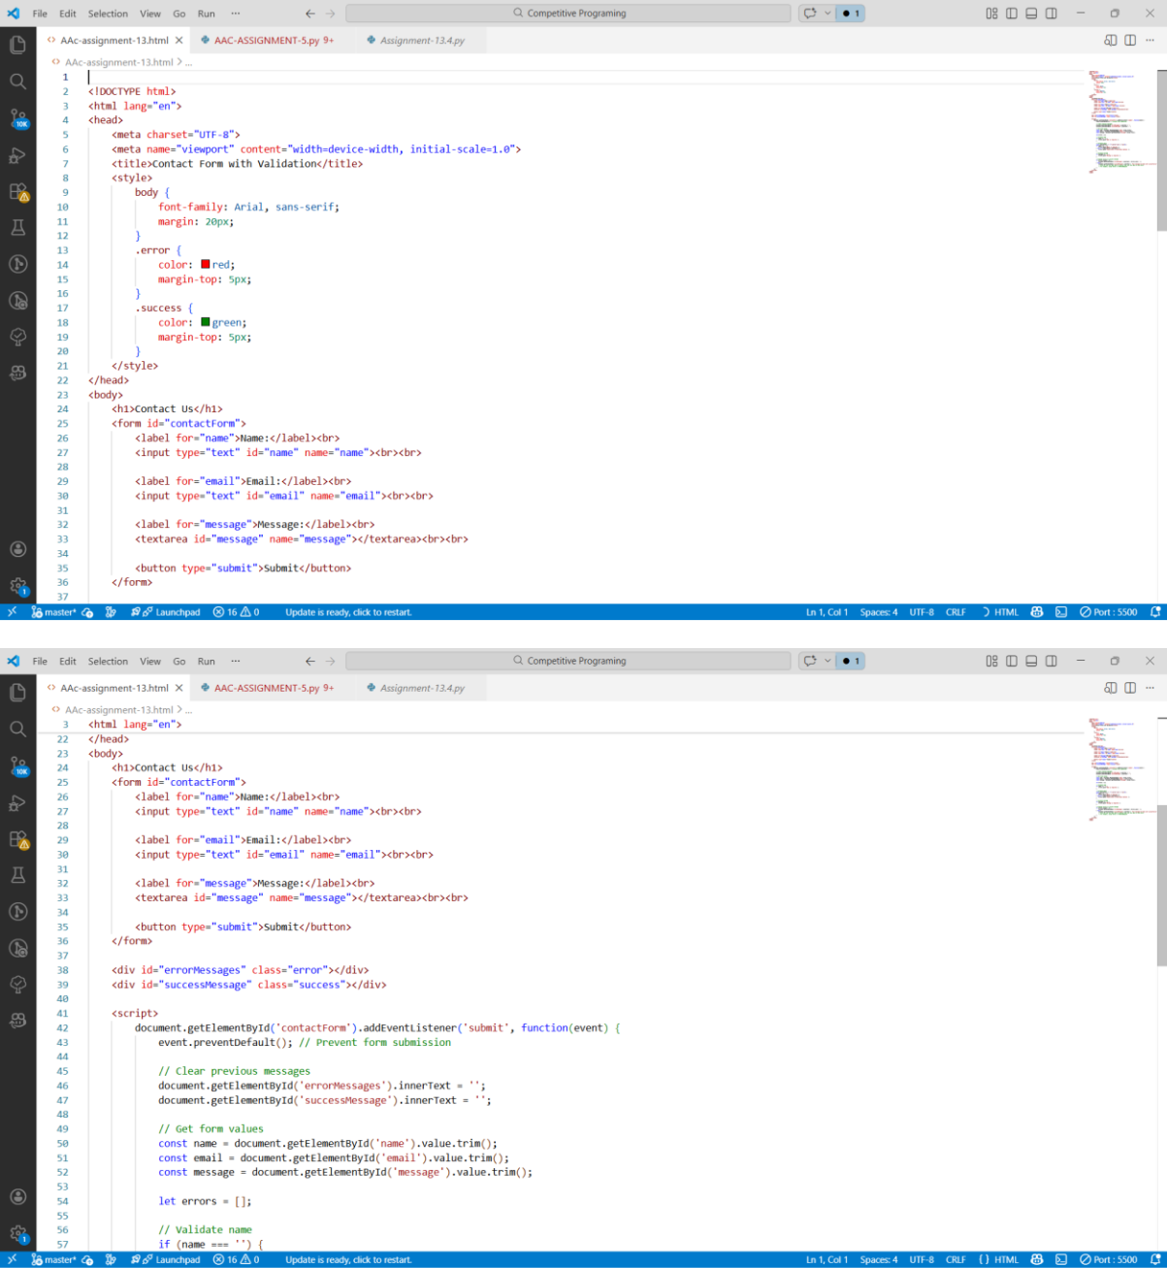

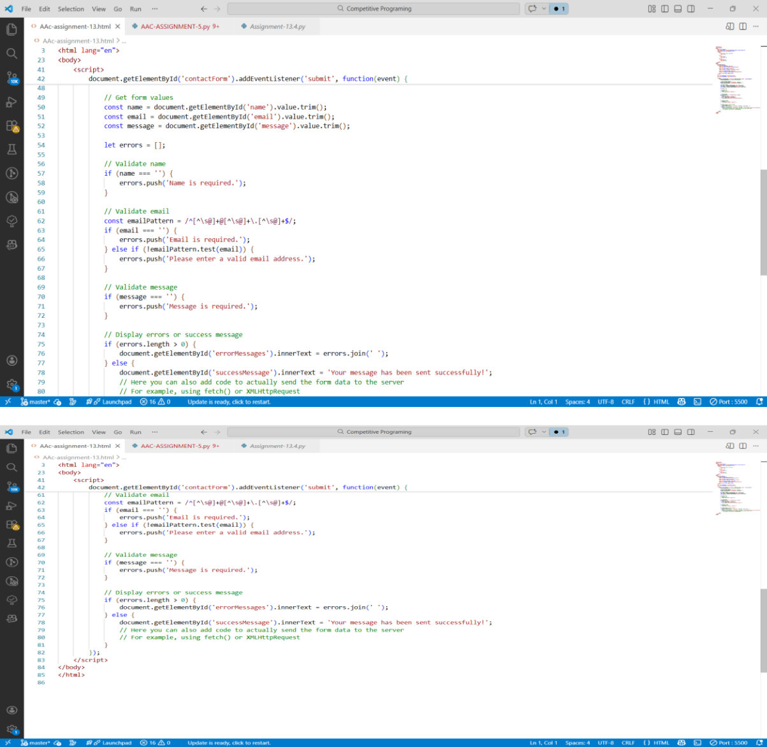

Output:
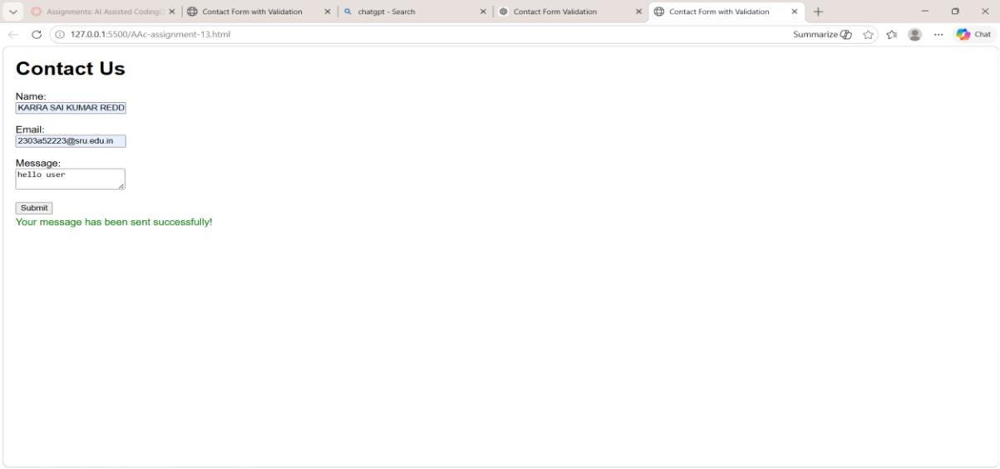

Justification:

Client-side validation is important to ensure that user input is correct before it is sent to the server. By validating fields such as Name, Email, and Message, the system prevents empty or incorrect data from being submitted. The email format check ensures that the user enters a valid email address, which helps maintain data quality. Displaying clear error messages improves user experience by guiding users to correct their input immediately. This approach also reduces unnecessary server requests and improves the overall efficiency and reliability of the web application.

Task 4: Dynamic List Management for a Product Page

Scenario

A product listing page needs to add or remove items dynamically without refreshing the page.

Task Description

- Create a simple HTML list to display items.

- Use AI to generate JavaScript that:

- Adds a new item when an “Add” button is clicked

  - Removes the last item when a “Remove” button is clicked

- Ensure the DOM updates dynamically.

Prompt:

Generate a simple HTML product list with JavaScript that allows users to dynamically add items to the list and remove the last item using "Add" and "Remove" buttons without refreshing the page.

Code:
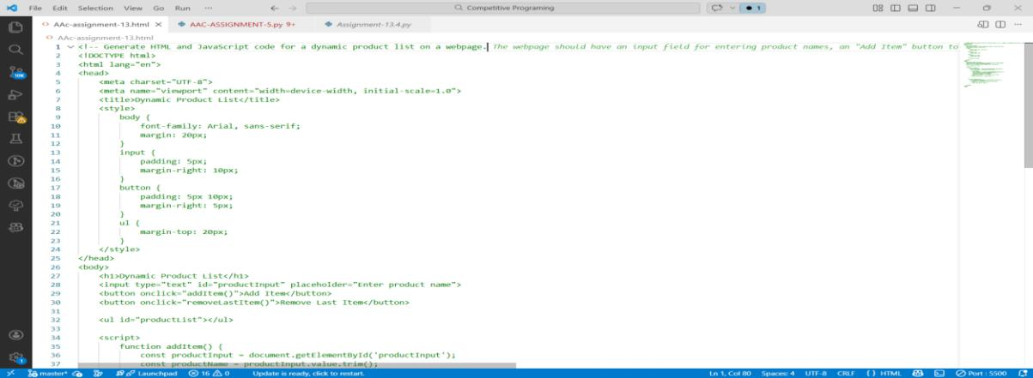

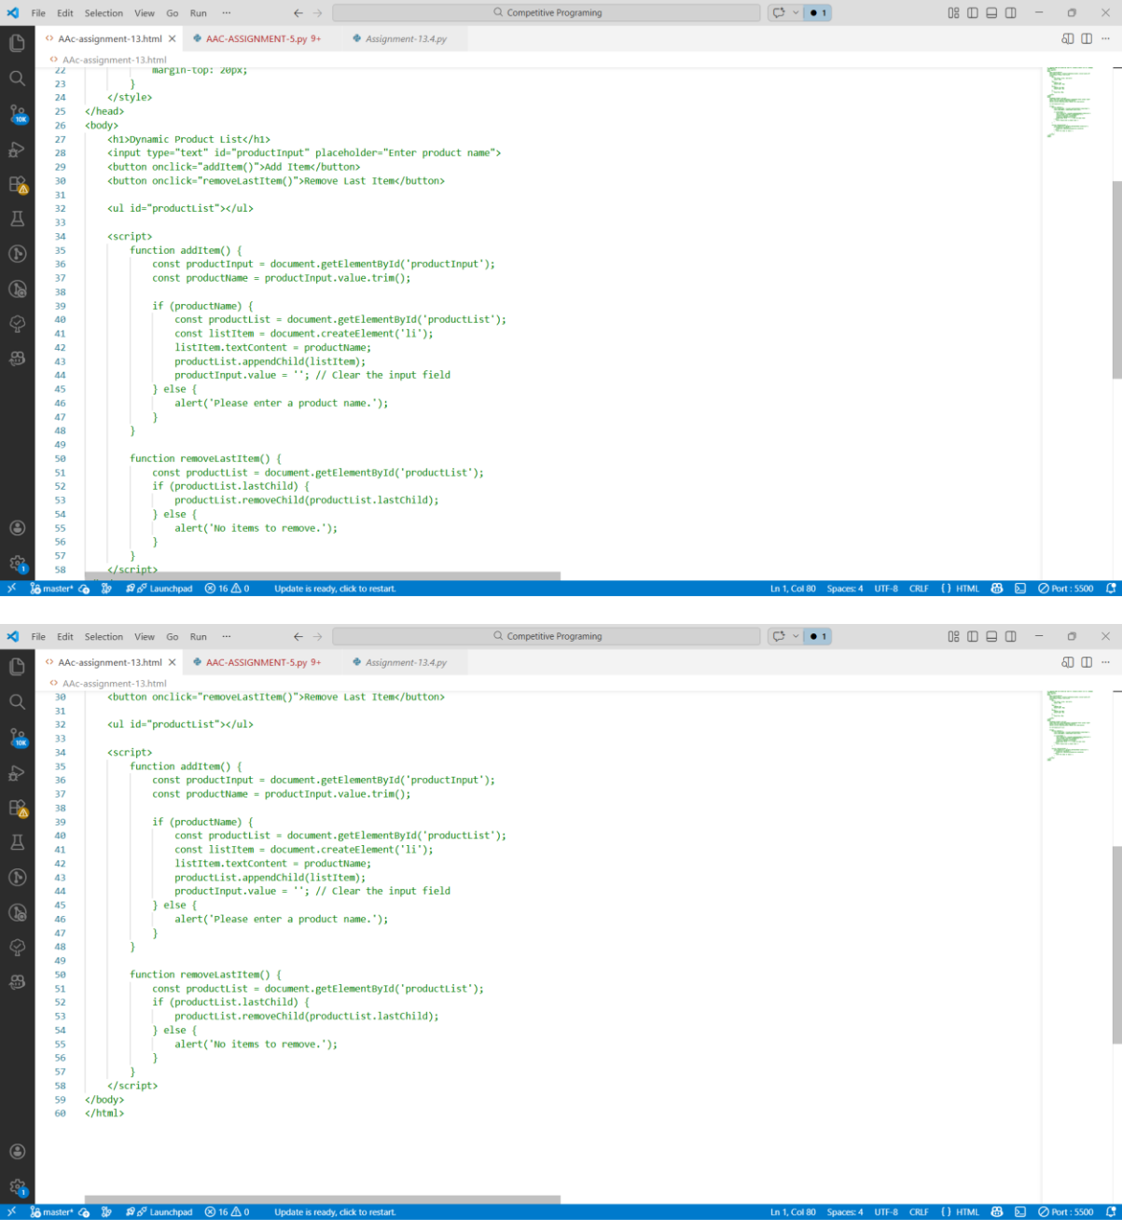
Output:
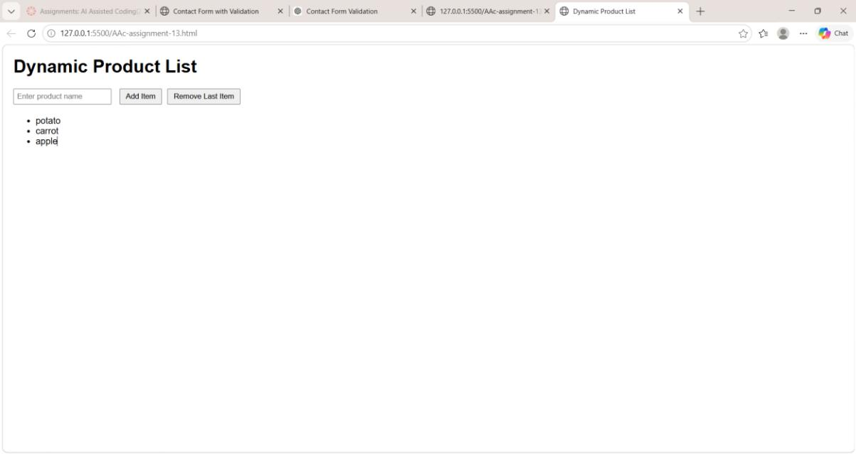

Justification:

Dynamic list management allows web pages to update content without reloading the page. By using JavaScript DOM manipulation, items can be added or removed from the product list instantly when the user clicks the Add or Remove buttons. This improves interactivity and provides a smoother user experience. It also demonstrates how modern web applications handle real-time updates efficiently, which is commonly used in e-commerce platforms and interactive websites.

Task 5: Modal Popup for User Notifications

Scenario

You are building a user notification popup for announcements or alerts on a website.

Task Description

- Use AI to help generate:

- HTML structure for a modal popup

- CSS styling with a semi-transparent background overlay

- JavaScript to open and close the modal

Include multiple ways to close the modal (button or overlay click).

Prompt:

Generate simple HTML, CSS, and JavaScript code for a modal popup notification on a webpage. Include a semi-transparent background overlay and a button to open the modal. The modal should close when the user clicks the close button or the overlay.

Code:
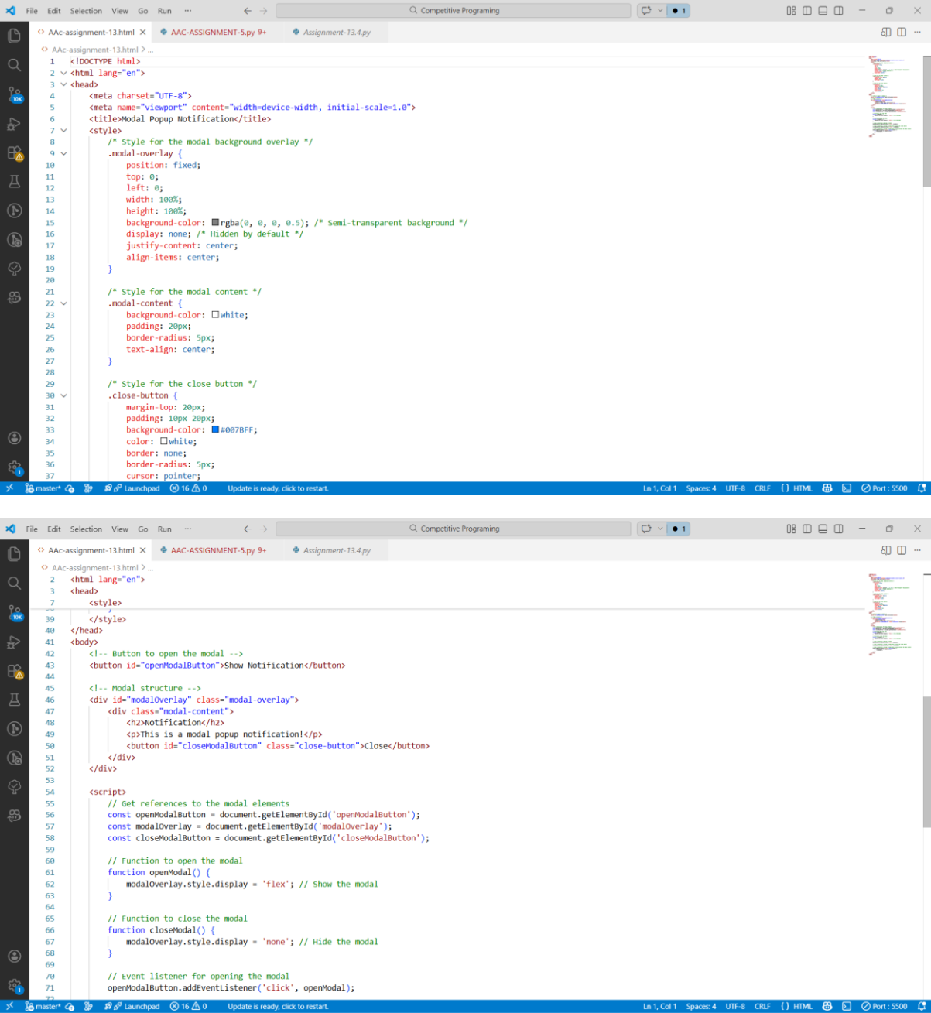

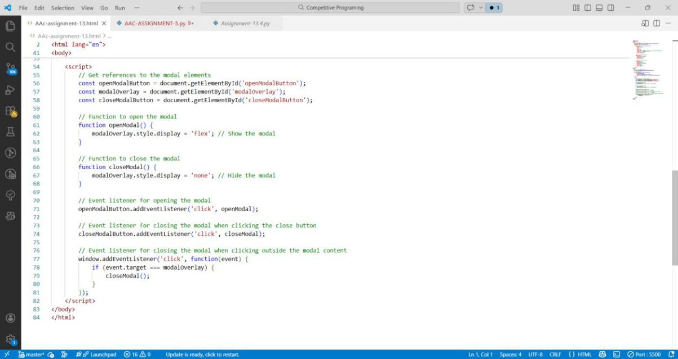

Output:
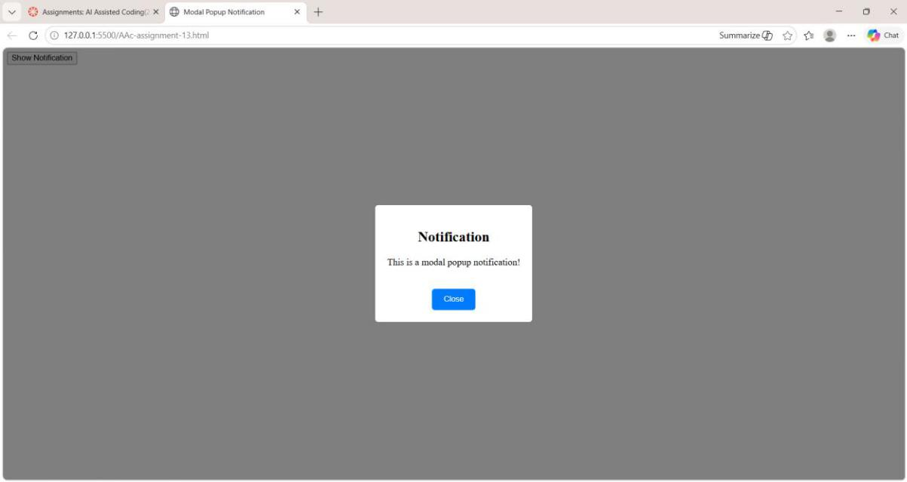

Justification:

A modal popup is commonly used on websites to display important notifications, announcements, or alerts without navigating to another page. The modal appears on top of the existing content with a semi-transparent overlay, which focuses the user’s attention on the message. Using JavaScript to open and close the modal dynamically improves user interaction and avoids page reloads. Providing multiple ways to close the modal, such as clicking a close button or the overlay, enhances usability and accessibility. This approach is widely used in modern web applications to deliver information effectively while maintaining a smooth user experience

